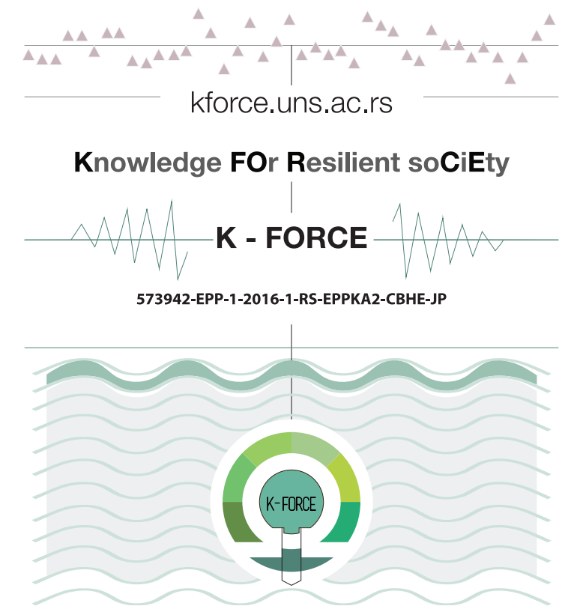
Dissemination and Exploitation Plan

Project Acronym: | K-FORCE
Project full title: | Knowledge FOr Resilient soCiEty
Project No: | 573942-EPP-1-2016-1-RS-EPPKA2-CBHE-JP
Funding Scheme: | ERASMUS+
Coordinator: | University of Novi Sad
Project start date: | October 15, 2016
Project duration: | 36 months

VERSIONING AND CONTRIBUTION HISTORY

Version | Date | Revision Description | Partner responsible
v.01 | 15.01.2017. | First draft version | UT (Elona Pojani)
v.02 | 11.02.2017. | Second draft version | UNS (Danijela Ciric)

Table of Content
INTRODUCTion 4
BRIEFLY ABOUT THE K-FORCE PROJECT 4
THE PURPOSE OF DISSEMINATION AND EXPLITATION 4
ROLE OF EACH PARTNER IN DISSEMINATION ACTIVITIES 5
DISSEMINATION AND EXPLOITATION STRATEGY 6
WHY DISSEMINATION AND EXPLOITATION PLAN 6
K-FORCE DISSEMINATION STRATEGY 6
TARGET GROUPS 9
IMPLEMENTATION OF THE PLAN 11
DISSEMINATION TOOLS 11
K-FORCE PROJECT WEBSITE 11
K-FORCE E-LIBRARY 12
K-FORCE VISUAL IDENTITY 13
THE K-FORCE LOGO 13
K-FORCE PROJECT BROCHURE 14
OTHER PRINT MATERIALS 16
K-FORCE VISUAL IDENTITY 13
DISSEMINATION ACTIVITIES AND EVENTS 19
EXECUTION OF MEDIA, ENROLMENT AND LLL CAMPAIGNS 19
ORGANIZATION OF 3 K-FORCE SYMPOSIA 21
Evaluation of the effectiveness 23
TYPE/TARGET GROUP/DISSEMINATION LEVEL OF RESULTS 23
Annex 1 Dissemination table template 31
Annex 2 Scientific publications list template 31

INTRODUCTion

BRIEFLY ABOUT THE K-FORCE PROJECT
The aim of the K-FORCE project is to improve regional resilience to hazards and capability for regional cooperation in risk prevention and response and to ensure national professional resources and regional capacities in order to build regional-based disaster preparedness and a culture of safety and resilience at all levels according to EU Integration Strategies and National relevant strategies.
The overall broader objective to which K-FORCE project will contribute is to ensure national professional resources and regional capacity for resilient society.
In order to achieve this K-FORCE project will create effective, contemporary and sustainable Study Programs in the field of Disaster Risk Management and Fire Safety Engineering (DRM&FSE).
The specific project objectives:
- Modernization of Disaster Risk Management and Fire Safety Engineering Master Programme (MP) and development and implementation of new MPs/modules in WBC partners HEIs, in accordance to regional needs and contemporary EU trends.
- Development and implementation of Disaster Risk Management and Fire Safety Engineering PhD study programme in accordance to available resources, regional needs and European partners' expertize, in aim to ensure regional capacities and sustainable education and research in the field.
- Continuous professional development of employees in DRM&FSE sector in WBC, through creation and implementation of certified LLL courses for practitioners.
- To improve cooperation between project partners in order to modernize teaching and training process on novel technical and technological solutions, exploiting the ICT application.
K-FORCE project is aimed to benefit large number of WBR students, professionals, public bodies, private/public enterprises, employees, public and wide society. Dissemination first goal is to spread and embed the project result. Additionally, it will focus on achieving high levels of public awareness, especially youth and professionals as end users of educational services.

THE PURPOSE OF DISSEMINATION AND EXPLITATION
Activities serving the dissemination and exploitation of results are a way to showcase the work that has been done as part of the Erasmus+ project. Sharing results, lessons learned and outcomes and findings beyond the participating organisations will enable a wider community to benefit from a work that has received EU funding, as well as to promote the organisation’s efforts towards the objectives of Erasmus+, which attaches fundamental importance to the link between Programme and policies. Therefore each of the projects supported by the Programme is a step towards achieving the general objectives defined by the Programme to improve and modernise education, training and youth systems.
Definition of dissemination and exploitation of project results is outlined in Erasmus+ Annex II - Dissemination and exploitation of results in terms of: what, why, who, when, where and how.
Dissemination is a planned process of providing information on the results of programmes and initiatives to key actors. It occurs as and when the result of programmes and initiatives become available. In terms of the Erasmus+ Programme this involves spreading the word about the project successes and outcomes as far as possible. Making others aware of the project will impact on other organisations in the future and will contribute to raising the profile of the organisation carrying out the project. To effectively disseminate results, an appropriate process at the beginning of the project needs to be designed. This should cover why, what, how, when, to whom and where disseminating results will take place, both during and after the funding period.
Exploitation is a planned process of transferring the successful results of the programmes and initiatives to appropriate decision-makers in regulated local, regional, national or European systems, on the one hand, and (b) a planned process of convincing individual end-users to adopt and/or apply the results of programmes and initiatives, on the other hand. For Erasmus+ this means maximising the potential of the funded activities, so that the results are used beyond the lifetime of the project. It should be noted that the project is being carried out as part of an international programme working towards lifelong learning and supporting European policies in the field of education, training, youth and sport. Results should be developed in such a way that they can be tailored to the needs of others; transferred to new areas; sustained after the funding period has finished; or used to influence future policy and practice.
Dissemination and exploitation are therefore distinct but closely related to one another.

Role of each partner in Dissemination Activities
All partner institutions are actively involved in the fulfilment of agreed objectives defined in this document throughout activities defined in work package 8 “Dissemination and exploitation”.
University of Novi Sad (P1) - is participating in WP8. P1 coordinates the implementation of 8.2. and 8.3. activities, as well as media, enrolment and LLL campaigns. P1 will constantly deliver the training courses to public services and enterprises interested in educating their employees on DRM&FSE issues and willing to raise the level of disaster awareness of their employees. P1 will cooperate in organization of 1st Symposium KNOWLEDGE FOR RESILIENT SOCIETY K-FORCE 2017, 2nd STUDENTS FOR RESILIENT SOCIETY S-FORCE and working meetings. P1 will participate in all dissemination activities.
Higher Education Technical School of Professional Studies in Novi Sad (P2) - is participant in WP8. P2 will regularly provide information for dissemination on WEB Page and participate in implementation of 8.2. and 8.3. activities, as well as in media, enrolment and LLL campaigns. P2 will cooperate in organization of 1st Symposium K-FORCE 2017, 2nd STUDENTS FOR RESILIENT SOCIETY S-FORCE and working meetings. P2 will participate in all dissemination activities.
University of Tuzla (P3) - is participant in WP8. P3 will regularly provide information for dissemination on WEB Page and participate in implementation of 8.2. and 8.3. activities, as well as in media, enrolment and LLL campaigns. P3 will participate in all dissemination activities.
University of Banja Luka (P4) - is SCM of WG8. P4 will regularly provide information for dissemination on WEB Page and participate in implementation of 8.2. and 8.3. activities, as well as in media, enrolment and LLL campaigns. P4 will participate in all dissemination activities.
University of Tirana (P5) - is Chair of WG8. P5 will organise 3rd Symposium KNOWLEDGE FOR RESILIENT SOCIETY K-FORCE 2019 and working meeting in cooperation with P6. P5 will regularly provide information for dissemination on WEB Page and participate in implementation of 8.2. and 8.3. activities, as well as in media, enrolment and LLL campaigns. P5 will coordinate and participate in all dissemination activities.
EPOKA University (P6) - is participant in WP8. P6 will organise 3rd Symposium K-FORCE 2018 and working meeting in cooperation with P5. P6 will regularly provide information for dissemination on WEB Page and participate in implementation of 8.2. and 8.3. activities, as well as in media, enrolment and LLL campaigns. P6 will participate in all dissemination activities.
Technical University of Denmark (P7) - is a participant in WP8. P7 will regularly provide information for dissemination on WEB Page and participate in all dissemination activities.
Alburg University (P8) - is a participant in WP8. P8 will regularly provide information for dissemination on WEB Page and participate in all dissemination activities.
Lund University (P9) - is a participant in WP8. P9 will regularly provide information for dissemination on WEB Page and participate in all dissemination activities.
University of Ziline (P10) - is a participant in P10. They will regularly provide information for dissemination on WEB Page and participate in all dissemination activities.
University “Ss. Cyril and Methodius” in Skopje (P11) – is a participant in WP8. P11 will regularly provide information for dissemination on WEB Page and participate in all dissemination activities.
Protection and Rescue Directorate of Macedonia (P12) - is a Co-chairs of WG8. P12 will participate in all dissemination activities.
NUZOP RS (P13) - is a Co-chairs of WG8. P13 will participate in all dissemination activities.
European Youth Parliament Serbia (P14) – is a Co-chairs of WG8. P14 will participate in all dissemination activities.

DISSEMINATION AND EXPLOITATION STRATEGY

WHY DISSEMINATION AND EXPLOITATION PLAN
The objective of the Dissemination and Exploitation Plan is to identify and organise the activities to be performed in order to promote the exploitation of the project’s results and the widest dissemination of knowledge from the project. This document defines strategies for dissemination and exploitation activities, tools, target groups to be addressed, visibility requirements, overall dissemination calendar detailed for each dissemination events, as well as to propose the list of key results that could be exploited and multiplied after the project.
It is very important to have Dissemination and Exploitation Plan from the very beginning of the project and to update it regularly, with the consent of all partners.
As outlined in Erasmus+ projects guidelines: “Having a strong plan for dissemination and exploitation from the beginning of a project is a key priority and should form an integral part of the CBHE throughout its lifetime. The objective of dissemination and exploitation is to maximize the impact of project results by optimizing their value, strengthening their impact, transferring them to different contexts, integrating them in a sustainable way and using them actively in systems and practices at local and international levels.” (Erasmus+ Programme Capacity-Building projects in the field of Higher Education (E+CBHE) Guidelines for the Use of the Grant, 2016).

K-FORCE DISSEMINATION STRATEGY
The plan is expanded in two directions: towards the activities in order to enhance the potential of the project and the visibility of projects results in the all relevant sectors and stakeholders (scientific, engineering, economy, industrial and general government sector).
Main goals aimed to be achieved:
- To spread and embed the project result;
- To disseminate the results of the project to wider community;
- To achieve the visibility of the K-FORCE project and its results to all levels of stakeholders;
- To achieve high levels of public awareness, especially youth and professionals as end users of educational services;
- To ensure the best coordination and optimal use of project resources and results during and beyond the lifetime of the project.
The specific goals aimed to be achieved:
- Raising awareness about the challenges and the potential solutions provided by the project;
- Informing and educating the target audience as appropriate;
- Engaging a good number of representatives of the target audience groups to get input /feedback on their problems, expectations and experiences;
- Promoting the use of the project outputs and results through fostering decision making on use and implementation activities by practical knowledge transfer activities.
What should we do in order to achieve these goals?
- Develop, review and update dissemination plan for the project to ensure maximum visibility and impact of the project outcomes;
- Develop, maintain and promote K-FORCE Web site;
- Open/maintain e-library public access area;
- Plan and execute media campaigns related to all K-FORCE events;
- Organise 3 K-FORCE Symposia, with specific aims and target group;
- Plan and organize enrolment events;
- Continue to deliver LLL and custom-made courses to other stakeholders.
Related assumptions and risks:
- Continued interest of target groups;
- Willingness of media to cover visibility activities;
- Different social situation in the periods campaigns’ realisation;
- Technical problems with WEB page and other technical issues could cause delays in dissemination plan.
In compliance with ERASMUS+ recommendations, K-FORCE project will use various actions to ensure high project visibility and maximal impact. Activities at different stages of the project are:
Actions before the project:
- Drafting the plan;
- Definition of the expected impact;
- Consideration of the target groups.
- Developing project website.
Actions during the project:
- Design of the project visual identity;
- Developing and adapting promo material;
- Organization of dissemination events;
- Updating the dissemination plan and dissemination table with recent information;
- Maintaining project website;
- Contacting relevant media at local or regional level;
- Conducting regular activities such as information sessions, training, demonstrations...
- Assessing the impact on the target groups.
Actions after the project:
- Continuing further dissemination;
- Developing ideas for future cooperation;
- Evaluating achievement and impact;
- Contacting relevant media.
One of the first steps related to project dissemination and visibility is development of projects’ visual identity (logo) and design of promotional material (flyers, posters, etc.) that will be distributed during the projects span, and development of project website. Dissemination events and activities will include:
- The presentation of project results to students of secondary schools and prospective students through media events and enrolment campaigns;
- The organization of three 3 K-FORCE Symposia with specific aims and target group.
Dissemination of project results will be done by utilizing all available Internet communication channels: K-FORCE web page; flexible ICT learning platform; On-line library; social networks etc. Through these electronic means events announcements and news can be easily accessible by wider public. Consortium members will also investigate the use of their institutional website for engagement of social media networks to highlight project progress, upcoming events and publications.
Besides project events and dissemination of promo materials, the project teams’ members should also actively participate at events outside the project (conferences, meetings, round tables, etc.), where they should promote the project’s results and impact and establish contacts with relevant stakeholders.
Dissemination and exploitation of project and project results will be continued after the project ends, since its results will be contributing in the long run. The contribution will be, as specified above, in several levels, related to different target groups. The new and expanded knowledge in this area will be the main “service” which will be benefitting direct and indirect target groups. The new study programs developed in HEI in WBC will be a long-run asset which will continue to exist and after the life-time of the project. In addition, trainings of the teaching staff within the special mobility strand foreseen within this project will contribute to their overall academic profile, which will be exploited long into the future.
Finally, almost every project result that will be developed throughout the project (reports, deliverables, manuals, procedures, promo materials, good practices, etc.) will be visible and publicized on the project web-site, participating HEIs and non-HEIs web-sites, and thus accessible to HEIs staff, researchers and students. In this way, below mentioned, target groups will benefit from project results even after the project ends.

PUBLICITY
Any communication, publication or output resulting from the project, made by the beneficiaries jointly or individually, including at conferences, seminars or in any information or promotional materials (such as brochures, leaflets, posters, presentations, etc.), must indicate that the project has received European Union funding. This means that all material produced for project activities, training material, projects websites, special events, posters, leaflets, press releases, CD ROMs, etc. must carry the Erasmus+ logo and mention: "Co-funded by the Erasmus+ Programme of the European Union"

- Erasmus+ logo:

When displayed in association with another logo, the European Union emblem must have appropriate prominence.

- Disclaimer:

Any publication should mention the following sentence:

"This project has been funded with support from the European Commission. This publication [communication] reflects the views only of the author, and the Commission cannot be held responsible for any use which may be made of the information contained therein"

For other official EU language versions, please consult the following website: http://ec.europa.eu/dgs/education_culture/publ/graphics/beneficiaries_all.pdf

Target Groups
Successful dissemination means that at the very beginning of the project partners should identify the target groups which should or could be affected by project results and to tailor dissemination tools appropriately taking into account the audiences (end-users of the project activities and deliverables, stakeholders, experts or practitioners in the field and other interested parties, decision-makers at local, regional, national and European level, press and media, general public).
The overall broader objective to which K-FORCE project will contribute is to build a sustainable educational foundation in DRM&FSE field in WBCs and ensure national professional resources and regional capacity for resilient society. In the three years of K-FORCE project period, four curricula will be modernized or developed and implemented (in EN, SR, AL, BH) at WBC partner HEIs. The project subject area “Disaster Risk Management and Fire Safety Engineering” refers to a Multidisciplinary/Interdisciplinary priority amongst the national/regional priorities of Partner Countries, with Engineering and engineering trades as the dominant academic discipline. Other disciplines addressed by intended curricula are Environmental protection, Architecture and Construction, Civil Protection, Fire Science, Climatology, Hydrology, Seismology and Economy.
Because of these project characteristics, K-FORCE project is aimed to benefit large number of WBR students, professionals, public bodies, private/public enterprises, employees, public and wide society.
More specifically, the profile of each stakeholder is specified below:
- WB students – As the end users of educational services, students are the main stakeholder of this project. They will be the ones benefiting from the curriculum development in each of the WBU. The development of this new field in higher education is expected to give a great contribution to the future professional profile in the area. The students who will be targeted include both bachelor students of related fields, as well as professionals working in the field who wish to further their education by conducting a supplementary Master Program offered by this project in each higher education partner institution of WBU (as detailed below).

- Teachers and university staff – Academic university staff will perform teaching activities in both levels of education (master and PhD). Their ongoing information in relation to project aims, activities and results is very important to define what will be expected from them and how they should prepare new curricula for new MPs.

- Professionals and employees in all relevant sectors – As the current employees of the area will be targeted as potential students especially for the master programs in WBU, they are considered as important target groups. Accordingly, the dissemination activities will be specially directed to this group. Employees that should be targeted include:
  - employees of government institutions which deal with emergency events,
  - employees of environmental NGOs,
  - employees of private companies which are affected if a disaster occurs,
  - employees in agricultural sector,
  - employees of insurance companies, etc.

- Public bodies – Public bodies are those who have to ensure both physical and financial resilience when a disaster event occurs. Therefore they will be benefiting from several project activities and results such as: provision of new specialists in the area, development of online tools, increased knowledge in the field, public dissemination events, etc. Such public bodies include:
- Central government units in charge of disaster management such as the Directorate of Civil Emergencies (Albania), Ministry of Security of Bosnia and Herzegovina; Protection and Rescue Sector, Sector for International Cooperation and European Integrations (Bosnia and Herzegovina), Ministry of Interior, Sector for Emergency Management (Serbia), Ministry of Interior (Republic of Srpska), Protection and Rescue Directorate of the Republic of Macedonia (Macedonia).
- Local government units in charge of disaster management.

- Private/public enterprises – Enterprises prone to a disaster event are vulnerable as the event will affect their overall activity. They all will be benefitting from the expansion of knowledge in the area, therefore will be targeted by dissemination activities. Other private companies who will benefit from the project and thus addressed by the dissemination strategy are environmental NGOs and insurance companies, as their activity is directly and indirectly related to disaster management.

- Public and wide society – A disaster event affects the country in the long run. The main economic indicators are affected by the event. The GDP growth of the country decreases both in the year of the event, as well as in the following years. In the long run it is believed that if the public response to the disaster event is adequate, the GDP growth can recover and even increase above the levels before the event. Therefore the increase of knowledge in the area will benefit the wide society in the long run, even those who are not directly affected by the event, but will be eventually affected by the economic conditions after the event. For these reasons dissemination activities of this project has to be available to the general public, mainly through media means (public/local TV and newspapers/journals). Whoever is further interested would benefit from the open access to e-library to be created within this project.
The project partners should also try to disseminate the project results to other target groups such as:
- Other schools and organizations;
- Policy makers who could incorporate the project results in the national or regional education system;
- Other potential Erasmus+ partnerships
- The National Agencies
- Networks of influential experts...
The project plans will be flexible enough to allow target groups and other stakeholders to become involved during the different stages of the project. This will help to ensure that the project remains on track in terms of their needs. Their participation will also highlight the potential value of K-FORCE project as well as help to spread the news to other interested parties throughout Europe.

IMPLEMENTATION OF THE PLAN

DISSEMINATION TOOLS

K-FORCE PROJECT WEBSITE
As a central point for dissemination purposes, University of Novi Sad, has created the project website available under http://www.kforce.uns.ac.rs/ since September 2016. It contains all relevant information regarding the project, its objectives, expected results, news, upcoming relevant events and project partners.
The maintenance activities include adding of the electronic publications of the project that are intended for general public and for dissemination of the project.
The site also offers a private area in which the consortium members can access all documents necessary for the management of the project. The website is being continuously updated.Apart from dissemination purposes, the project website will also be used for project management, through its special area “Administration”.
The structure reflects it’s double purpose nature and is split in two sections, a private one and a public one. The main parts of the KFORCE Website are summarized here:
Public area (sub-categories):
1. HOME
2. ABOUT PROJECT (Project Rational, Objectives, Project Management, LMF, Work plan, K- Force visual identity)
3. CONSORTIUM MEMBERS (Lead partner, Member from Programme Countries, Members from partner Countries, Associated Members)
4. PROJECT RESULTS
5. EVENTS
6. GALLERY
7. CONTACT
8. PUBLICATIONS
9. E-LIBRARY
Private area:
- ADMINISTRATION

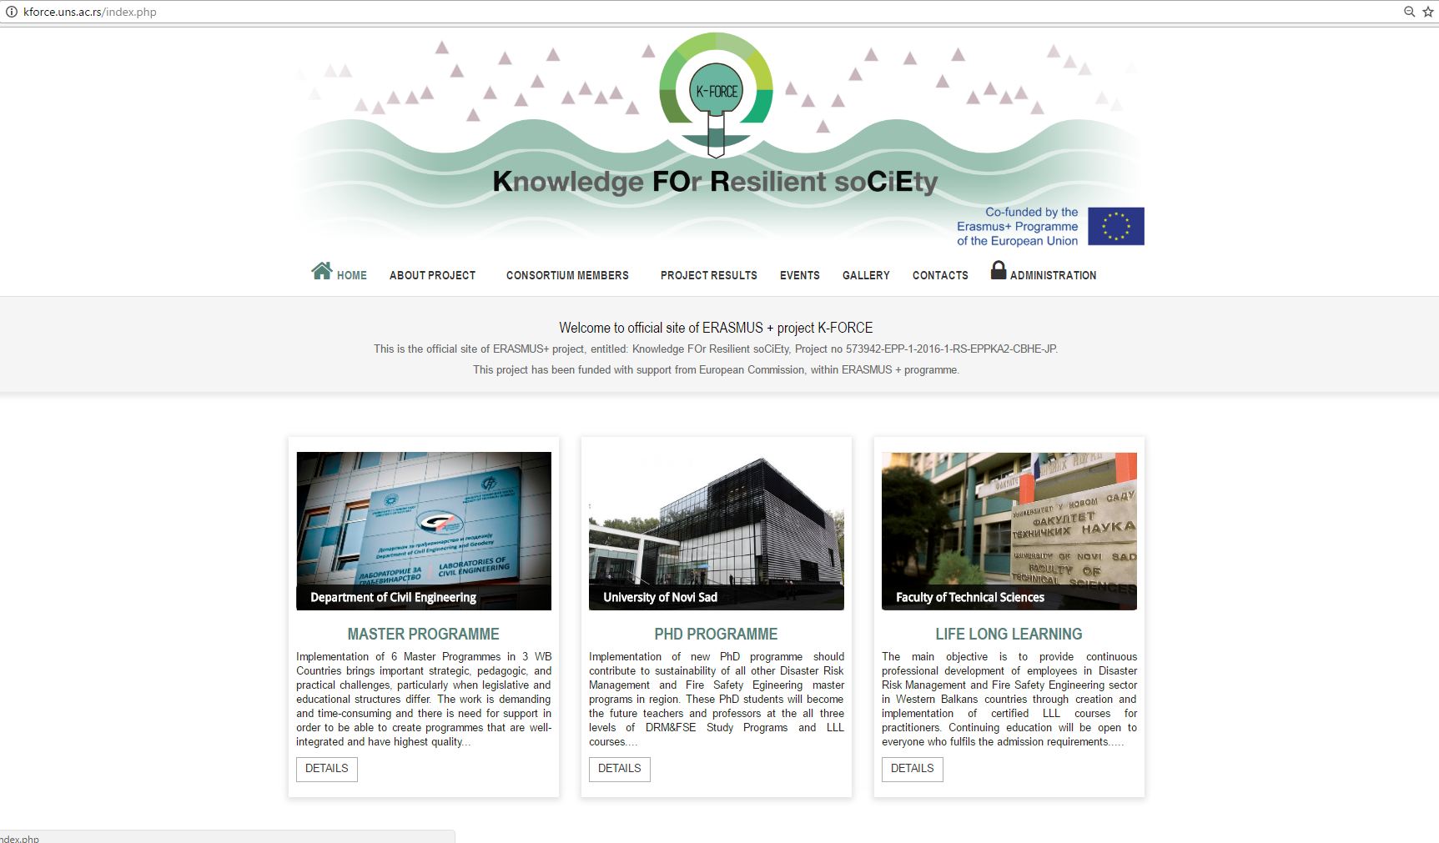
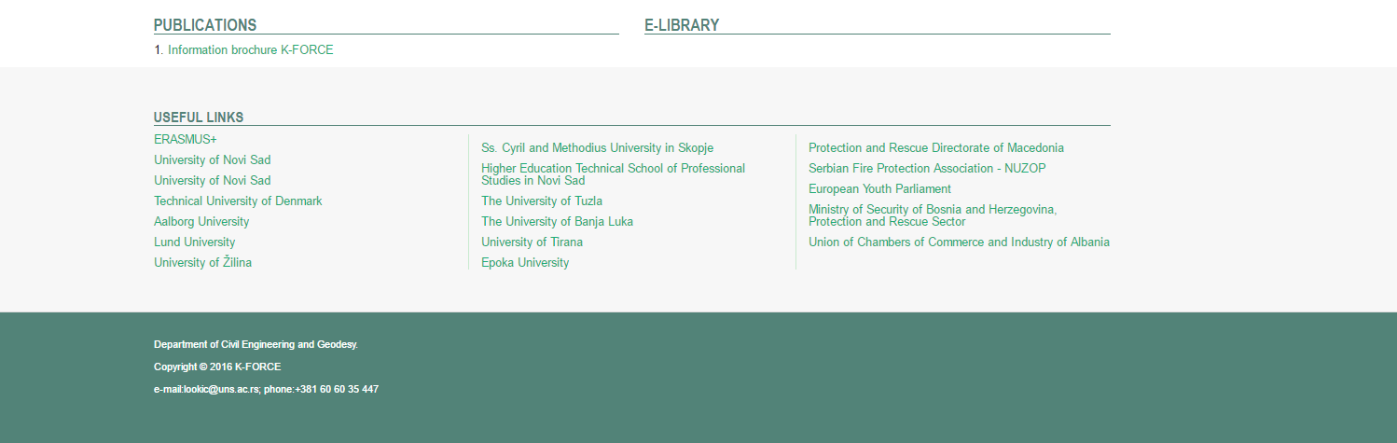
Figure 1: K-FORCE Website, Public Area (Home Page)
Following the project’s web dissemination strategy, news about K-FORCE project will be published in different languages EN, SR, AL, BiH.
All partners will regularly provide information for dissemination on website.
Web site will be linked to all partners’ web sites and other interested stakeholders and social networks.

K-FORCE E-LIBRARY
K-FORCE will support the production and adoption of Open Educational Resources in diverse European languages. For this purpose both a Glossary of DRM&FSE key words and terms and the K-FORCE On-line Library will be developed. In addition, Educational ICT based laboratories will be created in WBC HEIs with interoperability capabilities and K-FORCE On-line library will be providing international and regional case-study and research publications. These measures will insure common regional problem approach and knowledge compatibility also in accordance to contemporary trends in field of DRM&FSE. Public will have an open access to K-FORCE Web portal and K-FORCE On-line library where they will find guidebooks, glossary, curriculum, guides, textbooks, conference proceedings and other. This will be not only a mean of dissemination, but also will provide virtual mobility of teachers, students and trainees in the region and availability of materials.

ERASMUS+ PROJECT RESULTS PLATFORM
Amongst the different ways to disseminate and exploit results, beneficiaries can use the Erasmus+ Dissemination Platform developed by the European Commission for Erasmus+.to offer a comprehensive overview of projects funded under the Programme and to highlight good practice examples and success stories. The platform is as a useful tool in disseminating the outcomes of our project and makes available any tangible resources, products, deliverables and outputs which have resulted from funded projects. The selected projects are required to upload the results of the project to the Erasmus+ Dissemination Platform which can be consulted at:
http://ec.europa.eu/programmes/erasmus-plus/projects

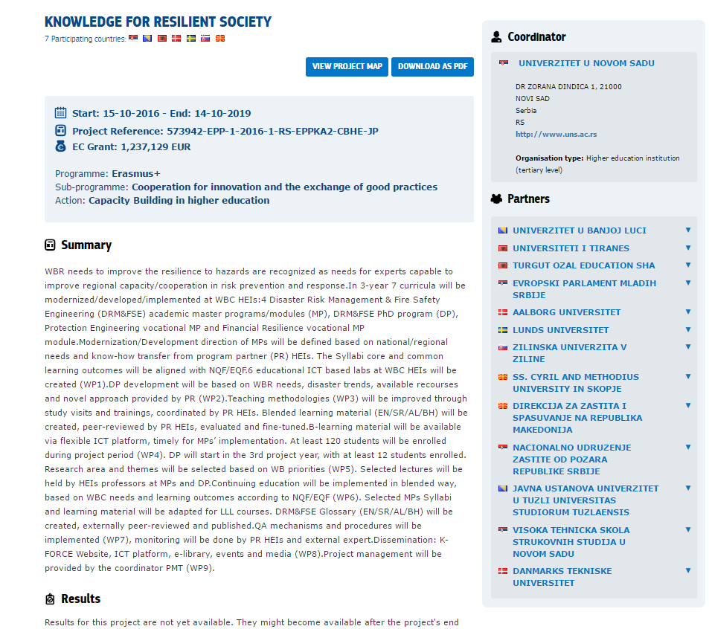
Figure 2: K-FORCE on Erasmus+ platform

K-FORCE VISUAL IDENTITY

Different documents and materials have been designed and will be printed for the purpose of dissemination of the K-FORCE project (logo, PPT template, News and Updates templates, and publication templates. The templates will be accompanying this document in electronic form, while the K-FORCE logo is presented in figure 2).

THE K-FORCE LOGO
The identity of the project is defined by unique graphical representation. For that purpose K-FORCE logo is designed and used in all project documents.
Figure 3: K-FORCE Logo

K-FORCE PROJECT BROCHURE
The information brochure is prepared to briefly present the K-FORCE project to potentially interested parties. The content of the brochure includes information, such as project aim, specific objectives and goals, work plan, main characteristics and list of partners.
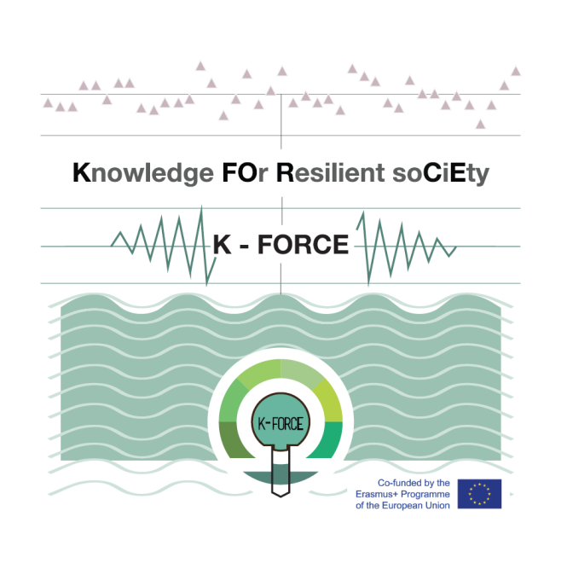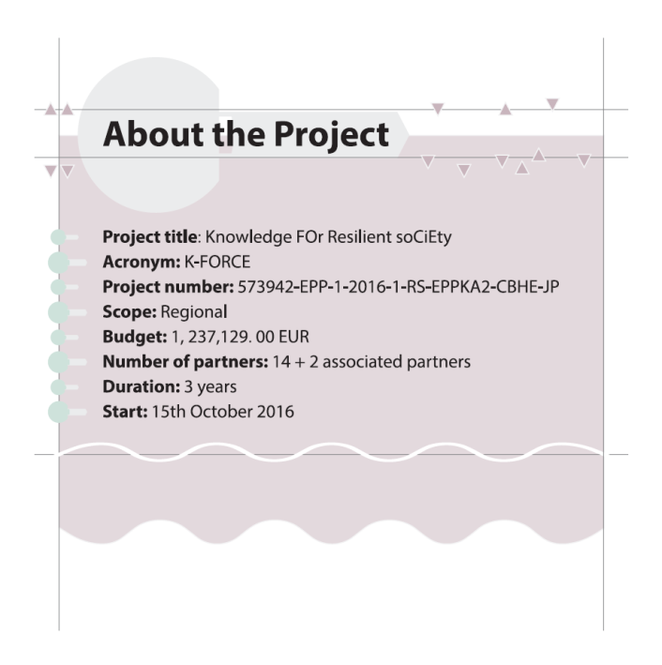

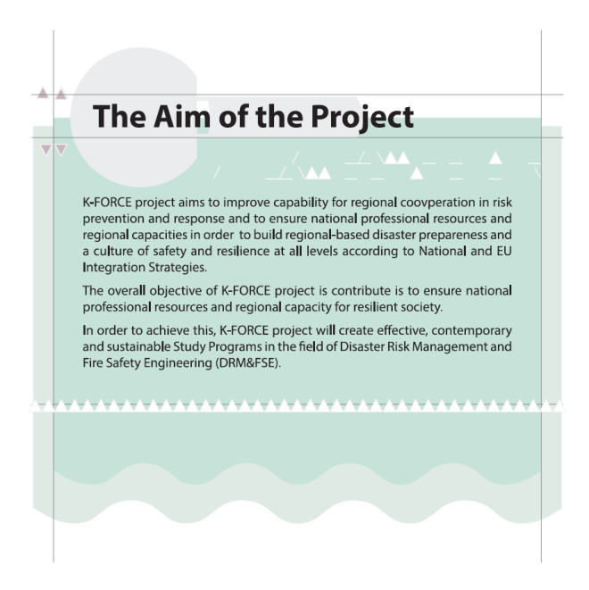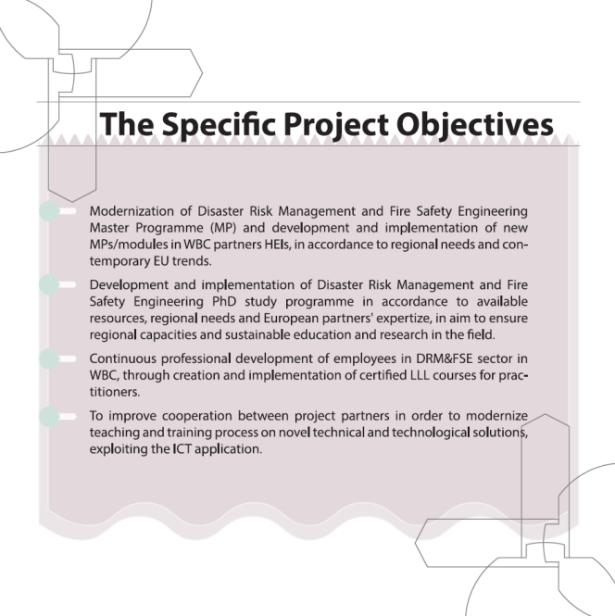
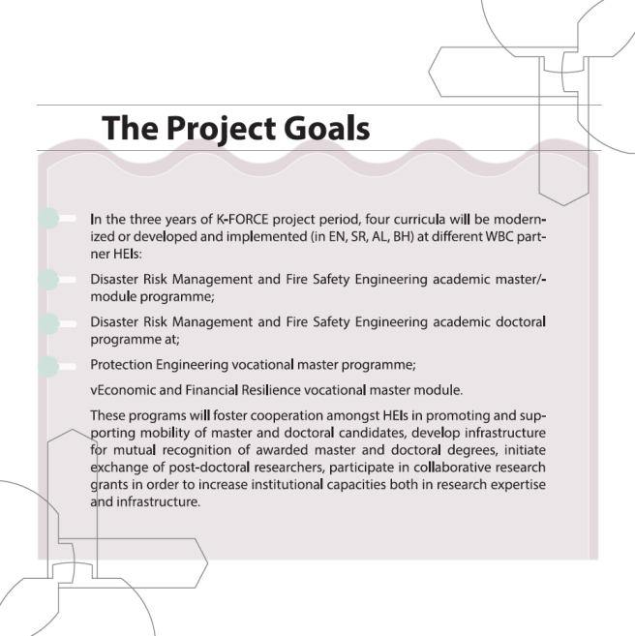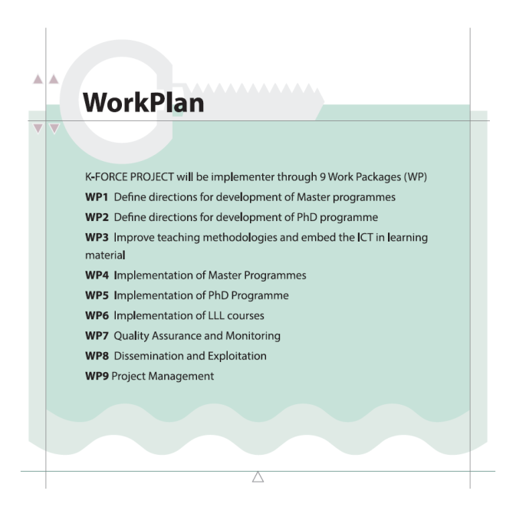
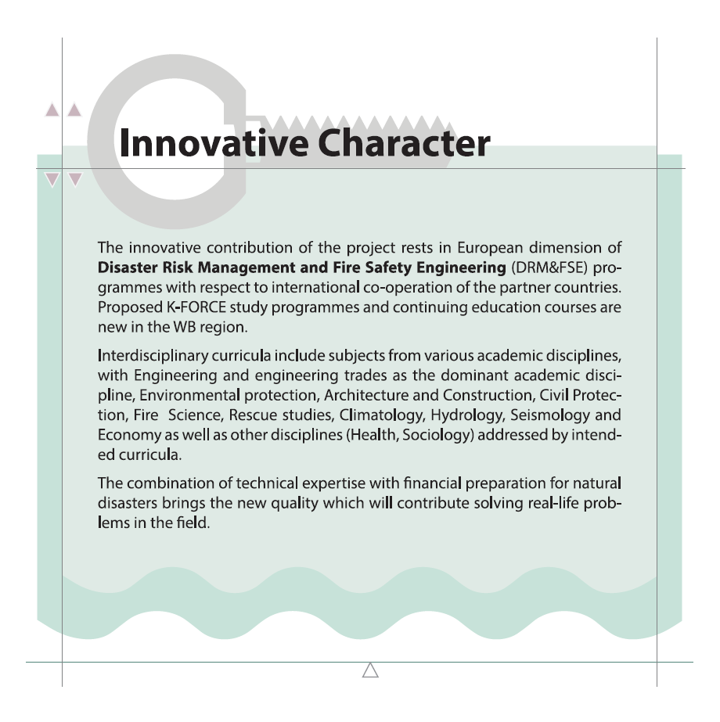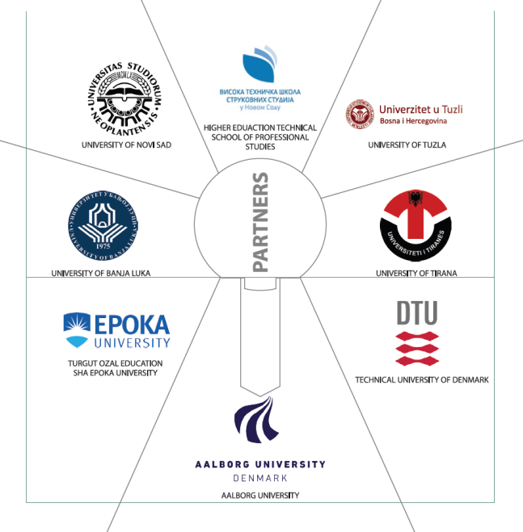
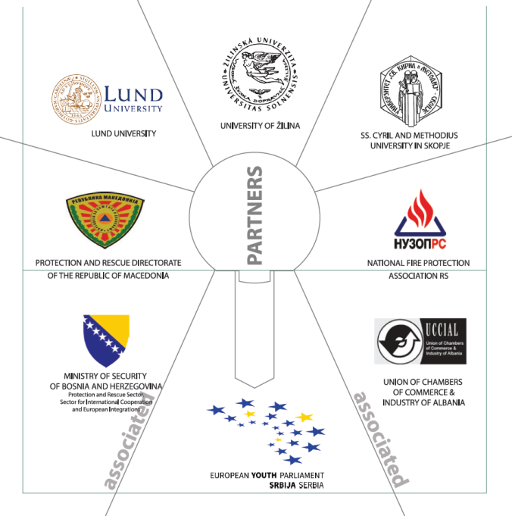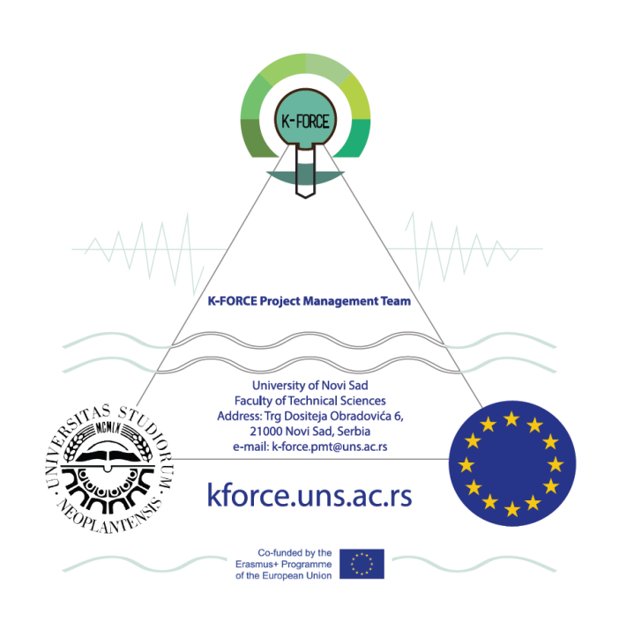
Figure 4: K-FORCE Brochure

Brochure can be found following the link: http://kforce.uns.ac.rs/images/Fajlovi/Information_brochure_K-FORCE.pdf.

OTHER PRINT MATERIALS
The most important print material for project promotion is flyers, poster, roll up, folder, notebook, which are designed for the use of dissemination during project events (partners meetings, study visits, consortium meetings, and symposia). Several small brochures and three-page fliers, designed to promote newly developed programs and teaching and training activities of the project, will be printed and distributed to potential students and DRM&FSE companies management. The aim of publications and promo materials is to make content available to the general public and end-users and to provide information on project- the background, objectives and description of work and expected results.

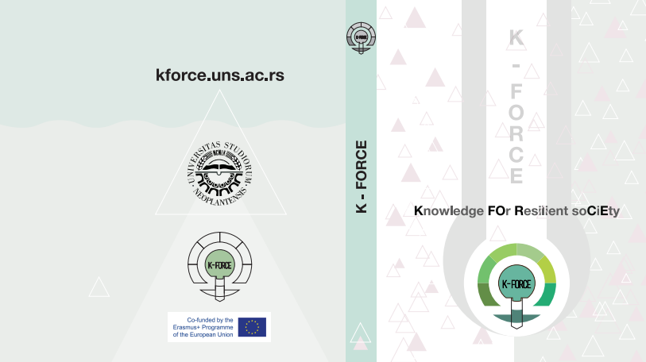
Figure 4: K-FORCE Folder
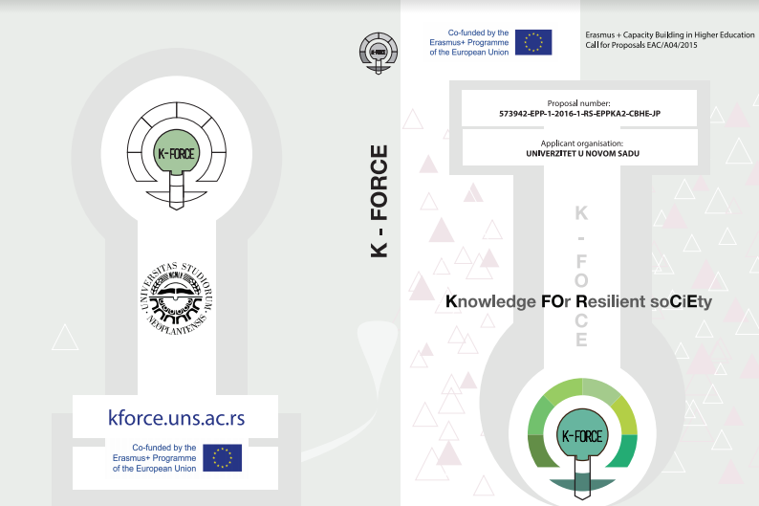
Figure 5: Project book cover
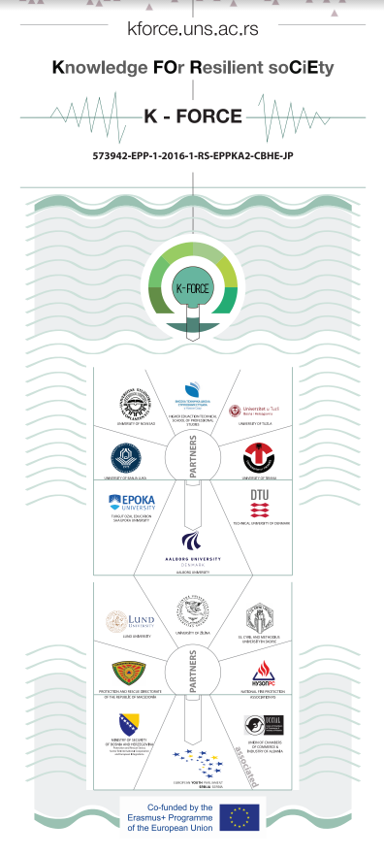
Figure 6: Roll-Up

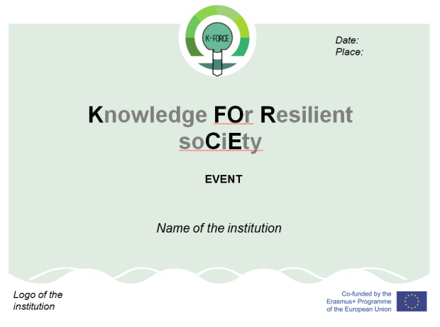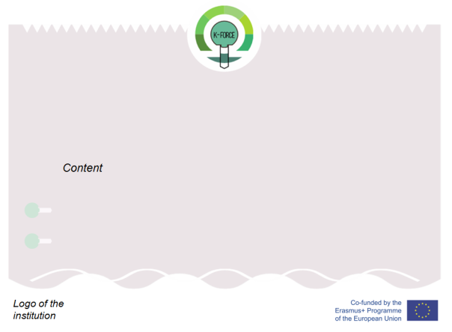

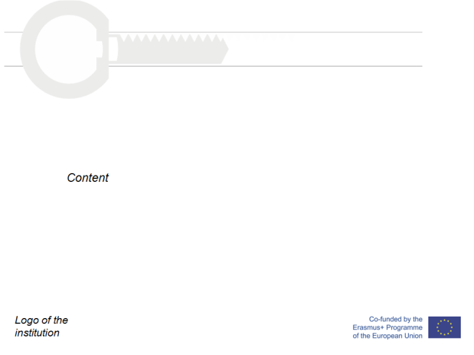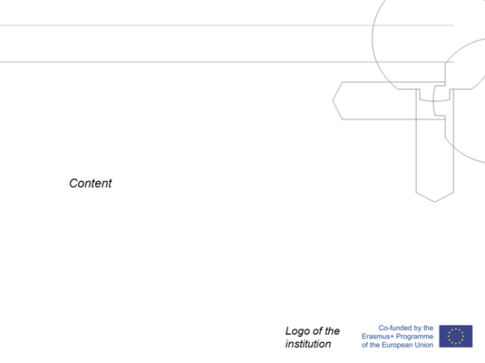

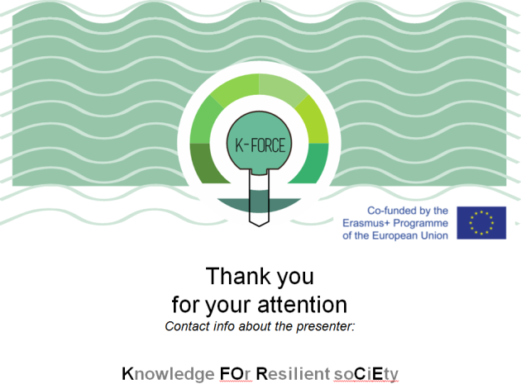
Figure 7: Project Presentations Template

Dissemination Activities and EVENTS

EXECUTION OF MEDIA, ENROLMENT AND LLL CAMPAIGNS
The project results will be presented to students of secondary schools and prospective students through various media events and enrolment campaigns targeting potential students of new MPs.
Table 1: Dissemination Campaigns Activity Plan
Institution performing the dissemination Campaign | Expected start of the first year of MPs | Information campaigns | Target Groups | Type of Campaign
University of Novi Sad | Academic Year 2017-2018 | During Spring 2017 and Winter and Spring 2018 | -Bachelor Students of related fields  -Secondary school students  -Professionals of relevant sectors such as employees of government institutions which deal with emergency events  -employees of environmental NGOs  -employees of private companies which are affected if a disaster occurs -employees in agricultural sector  -employees of insurance companies, etc. | - Info days  - Flyer distribution  - E-mail Notifications  - Special Meetings  - Short training Courses
Technical School of Professional Studies in Novi Sad | Academic Year 2017-2018 | During Spring 2017 and Winter and Spring 2018
University of Banja Luka | Academic Year 2018-2019 | During Winter and Spring 2018
University of Tuzla | Academic Year 2018-2019 | During Winter and Spring 2018
University of Tirana | Academic Year 2018-2019 | During Winter and Spring 2018
Epoka University | Academic Year 2018-2019 | During Winter and Spring 2018

Secondary school visits will be also conducted during these campaigns. In addition, training courses to public institutions and enterprises will be constantly delivered to all companies interested in educating their employees on DRM&FSE issues and willing to raise the level of disaster awareness of their employees. These services should be preceded by information campaigns to these institutions, in order for them to become acquainted with the potential of the project and how they can exploit it. Information campaigns should be conducted during the promotion of new study programs in each WB HEI in order to address the potential students of the programs.
Project dissemination should occur also through project partners institutions’ media services. Finally, project events should be followed by national and local televisions. Therefore, relevant media means should be identified in the beginning of the project and should be kept informed on project intermediate and other outcomes.
Table 2. Dissemination through media (internal and external) activity plan
Institution in charge the dissemination event | Activity Type | Media Type | Media Name | Frequency
University of Novi Sad | Announcement and link to project website | Web page | Web page of UNS  http://www.uns.ac.rs  http://www.gradjevinans.net/ | Once
 | Updates on project activity, events, news | Web Page | Web page of K-Force Project  http://kforce.uns.ac.rs/  http://www.gradjevinans.net/ | Very Frequently
 | Updates on project activity, events, news | Social Network | Facebook Profile of K-FORCE Project | Very Frequently
 | Short presentation on events related to the project | Web page | Web page of UNS  http://www.uns.ac.rs | Occasionally, upon event completion
 | Short presentation on events related to the project | Local/National TV or journal | TBD | Occasionally, upon event completion
Technical School of Professional Studies in Novi Sad | Announcement and link to project website | Web page | Web page of VTSNS: www.vtsns.edu.rs | Once
 | Short presentation on events related to the project | Web page | Web page of VTSNS: www.vtsns.edu.rs | Occasionally, upon event completion
 | Short presentation on events related to the project | Local/National TV or journal | TBD | Occasionally, upon event completion
University of Banja Luka | Announcement and link to project website | Web page | Web page of UBL: www.unibl.org | Once
 | Short presentation on events related to the project | Web page | Web page of UBL: www.unibl.org | Occasionally, upon event completion
 | Short presentation on events related to the project | Local/National TV or journal | TBD | Occasionally, upon event completion
University of Tuzla | Announcement and link to project website | Web page | Web page of UNTZ www.untz.ba | Once
 | Short presentation on events related to the project | Web page | Web page of UNTZ www.untz.ba | Occasionally, upon event completion
 | Short presentation on events related to the project | Local/National TV or journal | TBD | Occasionally, upon event completion
University of Tirana | Announcement and link to project website | Web page | Web page of Faculty of Economy  www.feut.edu.al | Once
 | Short presentation on events related to the project | Web page | Web page of Faculty of Economy  www.feut.edu.al | Occasionally, upon event completion
 | Short presentation on events related to the project | Local/National TV or journal | TBD | Occasionally, upon event completion
Epoka University | Announcement and link to project website | Web page | Web page of Epoka University www.epoka.edu.al | Once
 | Short presentation on events related to the project | Web page | Web page of Epoka University www.epoka.edu.al | Occasionally, upon event completion
 | Short presentation on events related to the project | Local/National TV or journal | TBD | Occasionally, upon event completion
Technical University of Denmark | Announcement and link to project website | Web page | Web page of DTU www.dtu.dk | Once
Aalborg University | Announcement and link to project website | Web page | Web page of AAL www.en.aau.dk | Once
Lund University | Announcement and link to project website | Web page | Web page of Lund University www.lunduniversity.lu.se | Once
University of Žilina | Announcement and link to project website | Web page | Web page of UNIZA www.uniza.sk | Once
SS. Cyril And Methodius University In Skopje | Announcement and link to project website | Web page | Web page of UKIM www.ukim.edu.mk | Once
Protection and Rescue Directorate of Macedonia - | Announcement and link to project website | Web page | Web page of PRDM www.nuzop.org.rs | Once
National Fire Protection Association | Announcement and link to project website | Web page | Web page of NUZOP RS www.nuzop.org.rs | Occasionally, upon event
European Youth Parliament | Announcement and link to project website | Web page | EYP  www.eyp.rs | Occasionally, upon event
 | Updates on project activity, events, news | Social Network | Facebook Page of EYP | Frequently

ORGANIZATION OF 3 K-FORCE SYMPOSIA
During the project’s lifetime, project partners will discuss and present intermediate and other outcomes at some major events which will take the form of Symposia. For this purpose, three Symposia will be organized, one at the end of each year of the project.
The 1st Symposium entitled KNOWLEDGE FOR RESILIENT SOCIETY K-FORCE 2017 will be organized by P13, P1, P2 and P14. Within the symposium partners will meet each other and present their programs and institutions as well as their views on the needs for knowledge in order to build a resilient society. The symposium will be open and project partners will be presented to the media and the general public will be made aware of the subject and the issues within the field of DRM&FSE. Media report of local/national/regional media will be provided.
Additionally, the needs and expected skills and knowledge to build a secure and resilient society will be presented in the form of essays on the need for HE in the field of DRM&FSE (P1-P11 and invited lectures); Presentation of the skills and necessary qualifications of experts in the opinion of the professional experts (P12, P13, P15, P16 and invited lectures); Necessity for education of children and youth (P14 invited lectures).
The 2nd Symposium entitled STUDENTS FOR RESILIENT SOCIETY S-FORCE will be organized by P1, P2, P13 and P14.
1st part of the symposium is reserved for presentation of student papers. This part of symposium is intended as a forum for PhD students and master students who aim to pursue PhD studies in DRM&FSE to have an opportunity to present the results of their scientific research.
The Symposium provides an opportunity to students of PhD studies to get acquainted with the research methods and the system of education of different countries and universities. Furthermore, the official program includes presentations of textbooks and selected lectures by esteemed scientists from P7-P11 as well as 'round tables' on current and popular topics in the DRM&FSE field. Partners P13 and P14 will be included in dissemination and survey of target groups.
2nd part of Symposium will be in line with the methodology of European Youth Parliament (EYP-workshops). All participants of the Symposium are appointed a working group – Committee. Each committee has its facilitator (P7-P11) and journalist (provided by P1-P6) which organize and follow the work of each Committee. A Committee is also given its own topic, which is in direct relation to the K-FORCE project theme. The workshop consists of three major parts, first of which is Teambuilding, first done with all the participants and then further in Committees. Teambuilding represents a series of exercises aimed at establishing a positive working environment and good communication inside the Committees. The second part is Committee Work, during which the participants are tasked with creating a resolution to the topic at hand. This is done by analyzing, discussing and formulating the problems and solutions to the topic, whilst consulting experts in the field. At the end of Committee Work, these problems and solutions are drafted, in the form of resolutions submitted in the European Parliament, to form a Resolution Booklet of the Conference. All of the resolutions from the Booklet are then individually debated on, attacked, defended and finally voted on by all the participants during the General Assembly, the third and final part of the working day. The aim of the General Assembly is to replicate the working procedures of the European Parliament.
Additionally, the event combines an unrivalled educational conference and presentation of newly establish Study Programs in the field of DRM&FSE. There is opportunity for students and teaching staff to speak with experts; find solutions to technical challenges and stay current with technological advances in DRM&FSE field. Experts and professionals will expose their papers on thematic what knowledge is necessary for building resilient society. Partners will present their programs and elaborate of possibilities and importance of education in the field of the DRM&FSE and continual learning (LLL). All Partners will participate with their presentations and lectures and consultations. Survey will be conducted during the event to ensure project quality.
The 3rd Symposium entitled KNOWLEDGE FOR RESILIENT SOCIETY 2 K-FORCE 2019 will be organized by P5 and P6. This will take the form with various presentations. All Project Partners participants and guest lectures will be admitted at no cost. Additional persons (non-project partner members or teaching staff) are welcome to attend, at a price which will be advised. Presentation of project results and conclusions and presentations of selected papers of end users of the project (master student papers and PhD student Papers), round table: discussion and definition of recommendations for further steps in improvements of education in DRM&FSE field.
The invited lectures presentations and selected workshops will be also taped and available on-line at Web site and Flexible learning platform.
Table 3. Plan of Symposia Dissemination Events
Event | The 1st Symposium - KNOWLEDGE FOR RESILIENT SOCIETY K-FORCE 2017 | The 2nd Symposium - STUDENTS FOR RESILIENT SOCIETY S-FORCE 2018 | The 3rd Symposium - KNOWLEDGE FOR RESILIENT SOCIETY 2 K-FORCE 2019
Organized by: | P13, P1, P2 and P14. | P1, P2, P13 and P14 | P5 and P6
Time Line | September 2017 | September 2018 | September 2019
Venue | Novi Sad, Serbia | Novi Sad, Serbia | Tirana, Albania
Aim and description: | Presentation and dissemination of partners views on the needs for knowledge in order to build a resilient society. | The Symposium provides an opportunity to students of PhD studies to get acquainted with the research methods and the system of education of different countries and universities. | Presentation of project results and conclusions and presentations of selected papers of end users of the project (master student papers and PhD student Papers).
Content | The needs and expected skills and knowledge to build a secure and resilient society will be presented in the form of:  - essays on the need for HE in the field of DRM&FSE (P1-P11 and invited lectures);  - presentation of the skills and necessary qualifications of experts in the opinion of the professional experts (P12, P13, P15, P16 and invited lectures);  - necessity for education of children and youth (P14 invited lectures). | The Symposium will be organized in two parts:  - 1st part of the symposium is reserved for presentation of student papers.  - The 2nd part of Symposium will be in line with the methodology of European Youth Parliament (EYP-workshops).  - Partners will present their programs and elaborate of possibilities and importance of education in the field of the DRM&FSE and continual learning (LLL). | The symposium will be composed of presentations and round tables for discussion and definition of recommendations for further steps in improvements of education in DRM&FSE field.

Evaluation of the effectiveness

The impact assessment is an essential part of the project. It evaluates achievements and generates recommendations for future improvements. Indicators can be used to measure progress towards goals.
The effectiveness of reaching the target audience groups and the impact of the communication activities should be monitored regularly. It is important to specify what a successful communication activity is before implementing the specific actions. It is important to check the actual performance of the communication activities by comparing the figures achieved to the success criteria.

Indicators used will be quantitative and qualitative:
- K-FORCE Web site, social network profiles and pages visits and document downloads
- Programmes, galleries and media reports on visits
- Numbers of participants involved in events, trainings...
- Media coverage
- Newsletters, e-bulletins, newspapers
- Number of registered users on the flexible ITC learning platform
- K-FORCE e-library visits and document downloads
- Mailing list of prospective students and of potential LLL attendees
- Yearly reports about dissemination activities
- Attendance lists from events and courses
- 3 Symposia Proceeding books published in PDF (distributed via USBs)
- Designed and printed project promotion material
- participation in public events
- Links with existing networks
- Transfer of information and know-how
- Impact on regional or local policy measures

TYPE/TARGET GROUP/DISSEMINATION LEVEL of results
Table 4. Type/target group/dissemination level of results
Expected Deliverable/Results/  Outcomes | Work Package and Outcome ref.nr | 1.1.
 | Title | Report on DRM&FSE MPs in EU and WBC
Type | ☒ Report
Target groups | ☒ Teaching staff  ☒ Administrative staff
Dissemination level | ☒ Department / Faculty  ☒ Institution |  | ☒ Local  ☒ Regional | ☒ National  ☒ International
Expected Deliverable/Results/  Outcomes | Work Package and Outcome ref.nr | 1.2.
 | Title | Report on WBC needs for DRM&FSE MPs and learning outcomes
Type | ☒ Report
Target groups | ☒ Teaching staff  ☒ Students
Dissemination level | ☒ Department / Faculty  ☒ Institution |  | ☐ Local  ☒ Regional | ☒ National  ☐ International
Expected Deliverable/Results/  Outcomes | Work Package and Outcome ref.nr | 1.3.
 | Title | Presentation of developed DRM&FSE MPs Curricula
Type | ☒ Report  ☒ Service/Product
Target groups | ☒ Teaching staff  ☒ Students
Dissemination level | ☒ Department / Faculty  ☒ Institution |  | ☒ Local  ☒ Regional | ☒ National  ☐ International
Expected Deliverable/Results/  Outcomes | Work Package and Outcome ref.nr | 1.4.
 | Title | Equipment procured, installed and activated, local staff trained in its usage
Type | ☒ Teaching material  ☒ Learning material  ☒ Training material  ☒ Report  ☒ Service/Product
Target groups | ☒ Teaching staff  ☒ Students  ☒ Trainees  ☒ Administrative staff  ☒ Technical staff  ☒ Librarians  ☒ Other
Dissemination level | ☒ Department / Faculty  ☒ Institution |  | ☒ Local  ☒ Regional | ☒ National  ☐ International
Expected Deliverable/Results/  Outcomes | Work Package and Outcome ref.nr | 2.1.
 | Title | Report on WB needs and EU trends in DRM&FSE PhD
Type | ☒ Report
Target groups | ☒ Teaching staff  ☒ Students  ☒ Administrative staff
Dissemination level | ☒ Department / Faculty  ☒ Institution |  | ☒ Local  ☒ Regional | ☒ National  ☐ International
Expected Deliverable/Results/  Outcomes | Work Package and Outcome ref.nr | 2.2.
 | Title | Report on teaching staff resources for MPs and PhD
Type | ☒ Report
Target groups | ☒ Teaching staff  ☒ Students  ☒ Administrative staff  ☒ Technical staff
Dissemination level | ☒ Department / Faculty  ☒ Institution |  | ☒ Local  ☒ Regional | ☒ National  ☐ International
Expected Deliverable/Results/  Outcomes | Work Package and Outcome ref.nr | 2.3.
 | Title | Report on compared PhD models and curricula
Type | ☒ Report
Target groups | ☒ Teaching staff  ☒ Students  ☒ Administrative staff
Dissemination level | ☒ Department / Faculty  ☒ Institution |  | ☒ Local  ☒ Regional | ☒ National  ☐ International
Expected Deliverable/Results/  Outcomes | Work Package and Outcome ref.nr | 2.4.
 | Title | Presentation of developed PhD Curriculum
Type | ☒ Report  ☒ Service/Product
Target groups | ☒ Teaching staff  ☒ Students  ☒ Administrative staff  ☒ Technical staff
Dissemination level | ☒ Department / Faculty  ☒ Institution |  | ☒ Local  ☒ Regional | ☒ National  ☐ International
Expected Deliverable/Results/  Outcomes | Work Package and Outcome ref.nr | 2.5.
 | Title | List of research PhD themes
Type | ☒ Report
Target groups | ☒ Teaching staff  ☒ Students
Dissemination level | ☒ Department / Faculty  ☒ Institution |  | ☒ Local  ☒ Regional | ☒ National  ☐ International
Expected Deliverable/Results/  Outcomes | Work Package and Outcome ref.nr | 3.1.
 | Title | Study visits reports
Type | ☒ Event  ☒ Report
Target groups | ☒ Teaching staff  ☒ Other
Dissemination level | ☒ Department / Faculty ☒ Institution |  | ☒ Local  ☒ Regional | ☒ National  ☒ International
Expected Deliverable/Results/  Outcomes | Work Package and Outcome ref.nr | 3.2.
 | Title | Report on agreed modalities of using ICT for b-learning
Type | ☒ Event  ☒ Report
Target groups | ☒ Teaching staff  ☒ Students  ☒ Trainees  ☒ Administrative staff  ☒ Technical staff  ☒ Librarians  ☒ Other
Dissemination level | ☒ Department / Faculty ☒ Institution |  | ☒ Local  ☒ Regional | ☒ National  ☐ International
Expected Deliverable/Results/  Outcomes | Work Package and Outcome ref.nr | 3.3.
 | Title | WBC teaching staff trained on DRM&FSE subjects and student-centred teaching skills
Type | ☒ Report  ☒ Service/Product  ☒ Training material
Target groups | ☒ Teaching staff  ☒ Other
Dissemination level | ☒ Department / Faculty ☒ Institution |  | ☒ Local  ☒ Regional | ☒ National  ☒ International
Expected Deliverable/Results/  Outcomes | Work Package and Outcome ref.nr | 3.4.
 | Title | b-learning materials for MPs and PhD developed
Type | ☒ Report  ☒ Teaching material  ☒ Learning material
Target groups | ☒ Teaching staff  ☒ Students  ☒ Trainees  ☒ Administrative staff  ☒ Technical staff  ☒ Librarians  ☒ Other
Dissemination level | ☒ Department / Faculty ☒ Institution |  | ☒ Local  ☒ Regional | ☒ National  ☒ International
Expected Deliverable/Results/  Outcomes | Work Package and Outcome ref.nr | 3.5.
 | Title | Report on evaluation of MPs and PhD learning material, fine-tuned MPs and PhD
Type | ☒ Report  ☒ Service/Product
Target groups | ☒ Teaching staff  ☒ Students  ☒ Trainees  ☒ Administrative staff  ☒ Technical staff  ☒ Librarians
Dissemination level | ☒ Department / Faculty ☒ Institution |  | ☒ Local  ☒ Regional | ☒ National  ☐ International
Expected Deliverable/Results/  Outcomes | Work Package and Outcome ref.nr | 4.1.
 | Title | Accredited MPs
Type | ☒ Report  ☒ Service/Product
Target groups | ☒ Teaching staff  ☒ Students  ☒ Administrative staff  ☒ Technical staff
Dissemination level | ☒ Department / Faculty  ☒ Institution |  | ☒ Local  ☒ Regional | ☒ National  ☐ International
Expected Deliverable/Results/  Outcomes | Work Package and Outcome ref.nr | 4.2.
 | Title | Report on WB needs and EU trends in DRM&FSE PhD
Type | ☒ Report
Target groups | ☒ Teaching staff  ☒ Students  ☒ Administrative staff  ☒ Other
Dissemination level | ☒ Department / Faculty ☒ Institution |  | ☒ Local  ☒ Regional | ☒ National  ☐ International
Expected Deliverable/Results/  Outcomes | Work Package and Outcome ref.nr | 4.3.
 | Title | Report on WB needs and EU trends in DRM&FSE PhD
Type | ☒ Report  ☒ Service/Product
Target groups | ☒ Teaching staff  ☒ Students  ☒ Trainees  ☒ Technical staff
Dissemination level | ☒ Department / Faculty ☒ Institution |  | ☒ Local  ☒ Regional | ☒ National  ☐ International
Expected Deliverable/Results/  Outcomes | Work Package and Outcome ref.nr | 4.4.
 | Title | Report on WB needs and EU trends in DRM&FSE PhD
Type | ☒ Teaching material  ☒ Learning material  ☒ Report  ☒ Service/Product
Target groups | ☒ Teaching staff  ☒ Students  ☒ Technical staff  ☒ Other
Dissemination level | ☒ Department / Faculty  ☒ Institution |  | ☒ Local  ☐ Regional | ☒ National  ☐ International
Expected Deliverable/Results/  Outcomes | Work Package and Outcome ref.nr | 4.4.
 | Title | Report on WB needs and EU trends in DRM&FSE PhD
Type | ☒ Teaching material  ☒ Learning material  ☒ Report  ☒ Service/Product
Target groups | ☒ Teaching staff  ☒ Students  ☒ Technical staff  ☒ Other
Dissemination level | ☒ Department / Faculty ☒ Institution |  | ☒ Local  ☐ Regional | ☒ National  ☐ International
Expected Deliverable/Results/  Outcomes | Work Package and Outcome ref.nr | 4.5.
 | Title | Report on 1st cohorts’ progress and satisfaction of students and staff
Type | ☒ Report
Target groups | ☒ Teaching staff  ☒ Students  ☒ Administrative staff  ☒ Technical staff
Dissemination level | ☒ Department / Faculty ☒ Institution |  | ☐ Local  ☒ Regional | ☐ National  ☐ International
Expected Deliverable/Results/  Outcomes | Work Package and Outcome ref.nr | 5.1.
 | Title | Accredited PhD programme
Type | ☒ Report  ☒ Service/Product
Target groups | ☒ Teaching staff  ☒ Students  ☒ Administrative staff
Dissemination level | ☒ Department / Faculty ☒ Institution |  | ☒ Local  ☒ Regional | ☒ National  ☐ International
Expected Deliverable/Results/  Outcomes | Work Package and Outcome ref.nr | 5.2.
 | Title | Students enrolled in PhD
Type | ☒ Report
Target groups | ☒ Teaching staff  ☒ Students  ☒ Administrative staff  ☒ Other
Dissemination level | ☒ Department / Faculty ☒ Institution |  | ☒ Local  ☒ Regional | ☒ National  ☐ International
Expected Deliverable/Results/  Outcomes | Work Package and Outcome ref.nr | 5.3.
 | Title | Report on WB needs and EU trends in DRM&FSE PhD
Type | ☒ Teaching material  ☒ Learning material  ☒ Report
Target groups | ☒ Teaching staff  ☒ Students  ☒ Administrative staff  ☒ Technical staff  ☒ Other
Dissemination level | ☒ Department / Faculty ☒ Institution |  | ☒ Local  ☐ Regional | ☒ National  ☐ International
Expected Deliverable/Results/  Outcomes | Work Package and Outcome ref.nr | 5.4.
 | Title | Report on 1st cohorts progress and satisfaction of students and staff
Type | ☒ Report
Target groups | ☒ Teaching staff  ☒ Students  ☒ Administrative staff
Dissemination level | ☒ Department / Faculty ☐ Institution |  | ☐ Local  ☐ Regional | ☐ National  ☐ International
Expected Deliverable/Results/  Outcomes | Work Package and Outcome ref.nr | 6.1.
 | Title | Report on WBC needs for LLL courses
Type | ☒ Report
Target groups | ☒ Teaching staff  ☒ Trainees  ☒ Other
Dissemination level | ☒ Department / Faculty ☒ Institution |  | ☒ Local  ☒ Regional | ☒ National  ☐ International
Expected Deliverable/Results/  Outcomes | Work Package and Outcome ref.nr | 6.2.
 | Title | Report on defined LLL outcomes
Type | ☒ Report
Target groups | ☒ Teaching staff  ☒ Trainees  ☒ Other
Dissemination level | ☒ Department / Faculty  ☒ Institution |  | ☒ Local  ☒ Regional | ☒ National  ☐ International
Expected Deliverable/Results/  Outcomes | Work Package and Outcome ref.nr | 6.3.
 | Title | Glossary published
Type | ☒ Learning material  ☒ Report  ☒ Service/Product
Target groups | ☒ Teaching staff  ☒ Students  ☒ Trainees  ☒ Administrative staff  ☒ Technical staff  ☒ Librarians  ☒ Other
Dissemination level | ☒ Department / Faculty  ☒ Institution |  | ☒ Local  ☒ Regional | ☒ National  ☒ International
Expected Deliverable/Results/  Outcomes | Work Package and Outcome ref.nr | 6.4.
 | Title | Selected learning material adapted for LLL purposes
Type | ☒ Training material  ☒ Report  ☒ Service/Product
Target groups | ☒ Teaching staff  ☒ Trainees  ☒ Other
Dissemination level | ☒ Department / Faculty  ☒ Institution |  | ☒ Local  ☒ Regional | ☒ National  ☐ International
Expected Deliverable/Results/  Outcomes | Work Package and Outcome ref.nr | 6.5.
 | Title | LLL courses delivered to professionals in blended way
Type | ☒ Training material  ☒ Report  ☒ Service/Product
Target groups | ☒ Teaching staff  ☒ Trainees  ☒ Other - DRM&FSE-oriented professionals from public services and enterprises
Dissemination level | ☒ Department / Faculty ☒ Institution |  | ☒ Local  ☒ Regional | ☒ National  ☐ International
Expected Deliverable/Results/  Outcomes | Work Package and Outcome ref.nr | 7.1.
 | Title | Quality Assurance mechanisms and procedures developed
Type | ☒ Report  ☒ Service/Product
Target groups | ☒ Other - K-FORCE Consortium
Dissemination level | ☒ Department / Faculty  ☒ Institution |  | ☐ Local  ☐ Regional | ☐ National  ☐ International
Expected Deliverable/Results/  Outcomes | Work Package and Outcome ref.nr | 7.2.
 | Title | The pools for different types of activities created
Type | ☒ Report
Target groups | ☒ Teaching staff  ☒ Students  ☒ Trainees  ☒ Administrative staff
Dissemination level | ☒ Department / Faculty  ☒ Institution |  | ☒ Local  ☒ Regional | ☒ National  ☒ International
Expected Deliverable/Results/  Outcomes | Work Package and Outcome ref.nr | 7.3.
 | Title | Learning material peer-reviewed
Type | ☒ Teaching material  ☒ Learning material  ☒ Report
Target groups | ☒ Teaching staff  ☒ Students  ☒ Trainees  ☒ Other- DRM&FSE-oriented professionals from public services and enterprises
Dissemination level | ☒ Department / Faculty  ☒ Institution |  | ☒ Local  ☒ Regional | ☒ National  ☐ International
Expected Deliverable/Results/  Outcomes | Work Package and Outcome ref.nr | 7.4.
 | Title | External review of the Glossary
Type | ☒ Report
Target groups | ☒ Teaching staff  ☒ Students  ☒ Administrative staff  ☒ Librarians  ☒ Other- DRM&FSE-oriented professionals from public services and enterprises
Dissemination level | ☒ Department / Faculty  ☒ Institution |  | ☒ Local  ☒ Regional | ☒ National  ☒ International
Expected Deliverable/Results/  Outcomes | Work Package and Outcome ref.nr | 8.1.
 | Title | Project dissemination plan created
Type | ☒ Report  ☒ Service/Product
Target groups | ☒ Teaching staff  ☒ Other - K-FORCE Consortium
Dissemination level | ☒ Department / Faculty  ☒ Institution |  | ☐ Local  ☐ Regional | ☐ National  ☐ International
Expected Deliverable/Results/  Outcomes | Work Package and Outcome ref.nr | 8.2.
 | Title | K-FORCE Web site developed, maintained and promoted
Type | ☒ Service/Product
Target groups | ☒ Teaching staff  ☒ Students  ☒ Trainees  ☒ Other- Press and media, general public, stakeholders, experts and practitioners in the field DRM&FS
Dissemination level | ☒ Department / Faculty  ☒ Institution |  | ☒ Local  ☒ Regional | ☒ National  ☒ International
Expected Deliverable/Results/  Outcomes | Work Package and Outcome ref.nr | 8.3.
 | Title | K-FORCE e-library open and maintained
Type | ☒ Report  ☒ Service/Product
Target groups | ☒ Teaching staff  ☒ Students  ☒ Trainees  ☒ Other- General public, stakeholders, experts and practitioners in the field DRM&FS
Dissemination level | ☒ Department / Faculty  ☒ Institution |  | ☒ Local  ☒ Regional | ☒ National  ☒ International
Expected Deliverable/Results/  Outcomes | Work Package and Outcome ref.nr | 8.4.
 | Title | Media, enrolment and LLL campaigns executed
Type | ☒ Event  ☒ Report  ☒ Service/Product
Target groups | ☒ Teaching staff  ☒ Students  ☒ Trainees  ☒ Other
Dissemination level | ☒ Department / Faculty  ☒ Institution |  | ☒ Local  ☒ Regional | ☒ National  ☐ International
Expected Deliverable/Results/  Outcomes | Work Package and Outcome ref.nr | 8.5.
 | Title | 3 K-FORCE Symposia organized
Type | ☒ Event  ☒ Report
Target groups | ☒ Teaching staff  ☒ Students  ☒ Trainees  ☒ Administrative staff  ☒ Technical staff  ☒ Other- Representatives of Public Entities (Local Government, Ministry of Education), Regional Branches of EYP and NUFS, Youth and Professional
Dissemination level | ☒ Department / Faculty  ☒ Institution |  | ☒ Local  ☒ Regional | ☒ National  ☐ International
Expected Deliverable/Results/  Outcomes | Work Package and Outcome ref.nr | 9.1.
 | Title | Minutes of the meetings
Type | ☒ Report
Target groups | ☒ Other- K-FORCE Consortium
Dissemination level | ☒ Department / Faculty  ☒ Institution |  | ☐ Local  ☐ Regional | ☐ National  ☐ International
Expected Deliverable/Results/  Outcomes | Work Package and Outcome ref.nr | 9.2.
 | Title | PM plan, procedures and Risk Plan adopted
Type | ☒ Report  ☒ Service/Product
Target groups | ☒ Other- K-FORCE Consortium
Dissemination level | ☒ Department / Faculty  ☒ Institution |  | ☐ Local  ☐ Regional | ☐ National  ☐ International
Expected Deliverable/Results/  Outcomes | Work Package and Outcome ref.nr | 9.3.
 | Title | Reports on Inter project coaching
Type | ☒ Report
Target groups | ☒ Other- K-FORCE Consortium
Dissemination level | ☐ Department / Faculty  ☒ Institution |  | ☐ Local  ☒ Regional | ☐ National  ☐ International
Expected Deliverable/Results/  Outcomes | Work Package and Outcome ref.nr | 9.4.
 | Title | Project activities reports and Partner expenses reports
Type | ☒ Report
Target groups | ☒ Other- K-FORCE Consortium
Dissemination level | ☒ Department / Faculty  ☒ Institution |  | ☒ Local  ☒ Regional | ☒ National  ☐ International

Annex 1. Dissemination table template
No.vcxv No. | Responsible  partner | Type of dissemination activity (event type/media type) | Event /Media name | Official organizer of the event | Venue, city, state | Date, Period | Targeted audience | Level (local, national, international)

Annex 2. Scientific publications list template
K-FORCE: LIST OF SCIENTIFIC (PEER REVIEWED) PUBLICATIONS, STARTING WITH THE MOST IMPORTANT ONES
No. | Title | Author/s | Title of the periodical or the series | Number, date or frequency | Publisher | Place of publication | Year of Publication | Relevant pages

